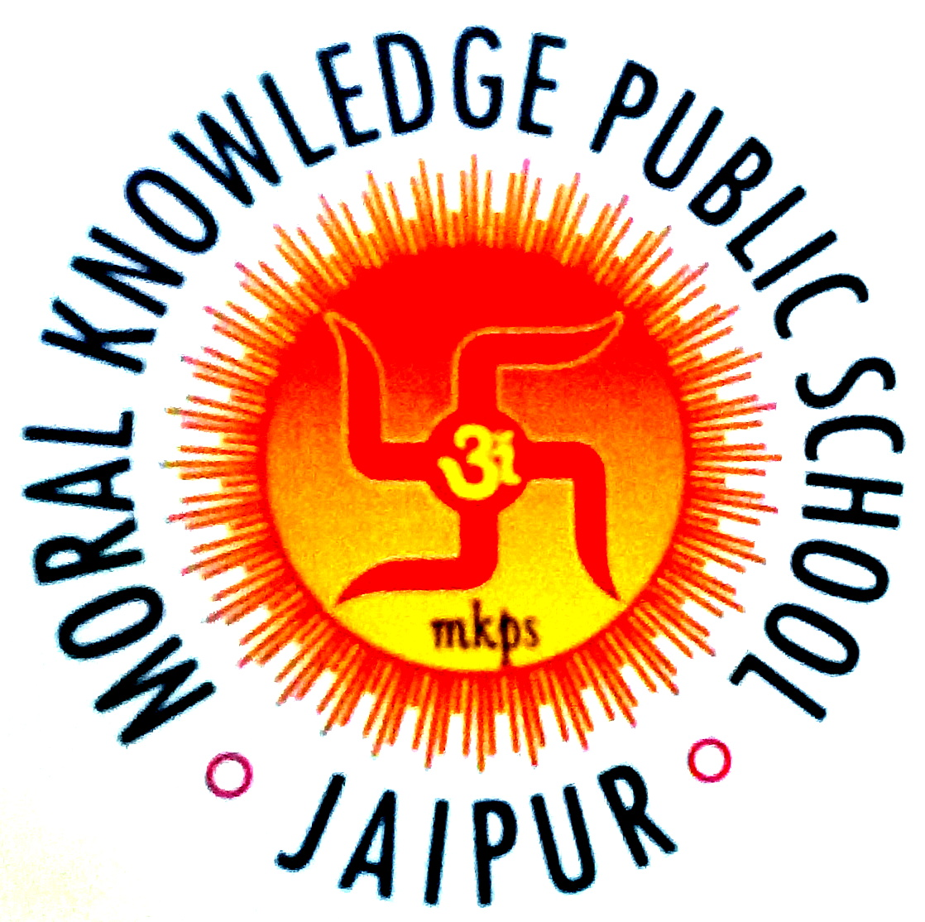

M.k. public sr. sec. school

Dept. Of Computer Science & Technology

XI & XII STANDARD

***C++ Programs & SQL***

Program File

**(12CS01)**

**General Information**

**Course : C++ and SQL Year Published :** 2019